AI-Assistant Assignment-9.1
e2303A52345
Batch-44
Problem 1:
Consider the following Python function:
def find_ max(numbers):
return max(numbers)
Prompt
Write a Python function that finds the maximum number from a list of numbers using the built-in max() function.
Document the function using three documentation styles: docstring, inline comments, and Google-style documentation. Then compare the three styles and explain which one is best for a mathematical utilities library.
Task:
• Write documentation for the function in all three formats:
(a) Docstring
(b) Inline comments
(c) Google-style documentation
• Critically compare the three approaches. Discuss the
advantages, disadvantages, and suitable use cases of each style.
• Recommend which documentation style is most effective
for a mathematical utilities library and justify your answer
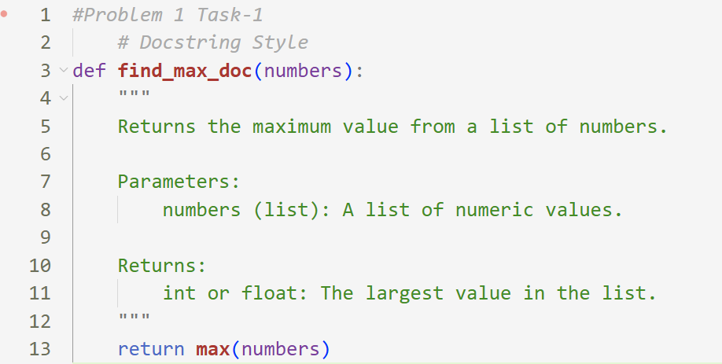
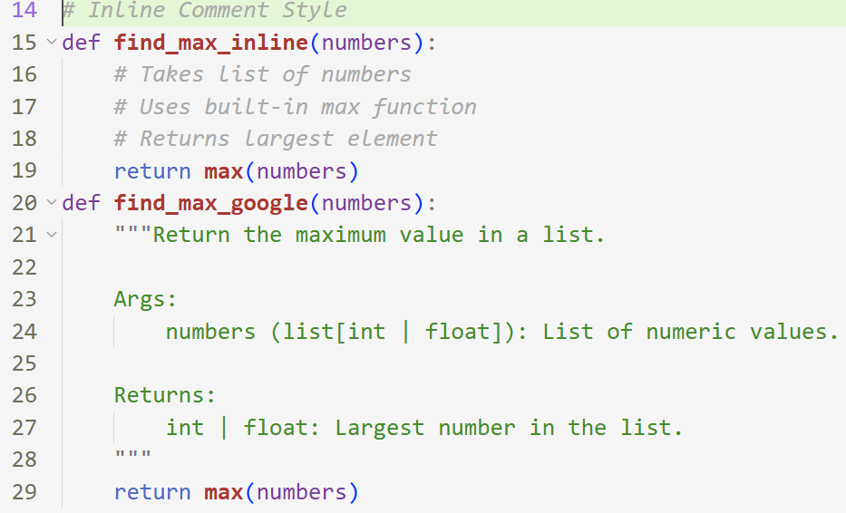
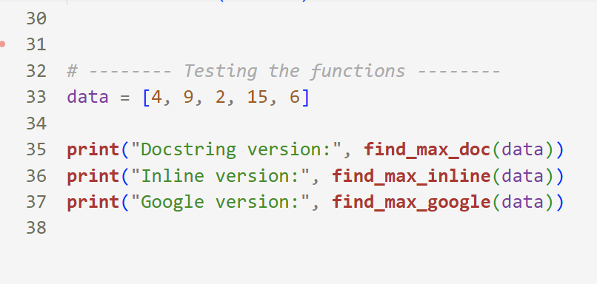
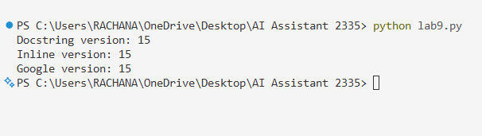
Description :
This task is about writing a Python function that finds the maximum number in a list and documenting it in three different styles: docstring, inline comments, and Google-style. It shows how documentation helps others understand what the function does, what input it needs, and what it returns. Among these, Google-style documentation is more clear and structured, so it is best for mathematical utility libraries.
Problem 2: Consider the following Python function:
def login(user, password, credentials):
return credentials.get(user) == password
Task:
1. Write documentation in all three formats.
2. Critically compare the approaches.
3. Recommend which style would be most helpful for new
developers onboarding a project, and justify your choice.
Prompt :
Write a Python function to check whether a user login is valid by comparing the given username and password with stored credentials in a dictionary. Document the function using docstring, inline comments, and Google-style documentation, then compare which style is best for new developers.
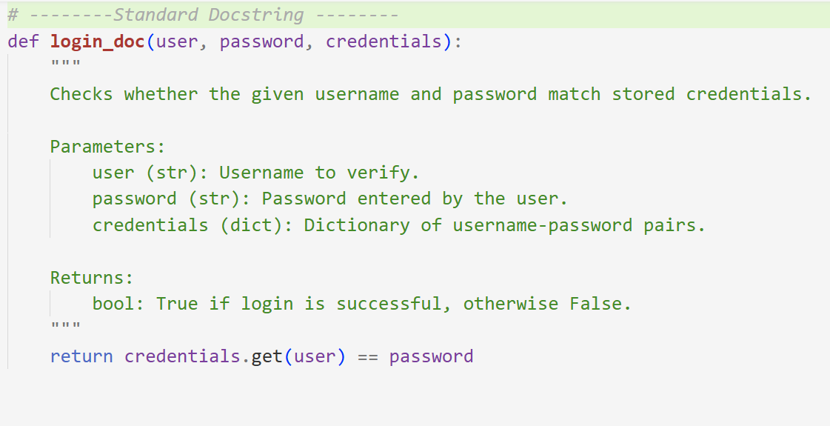
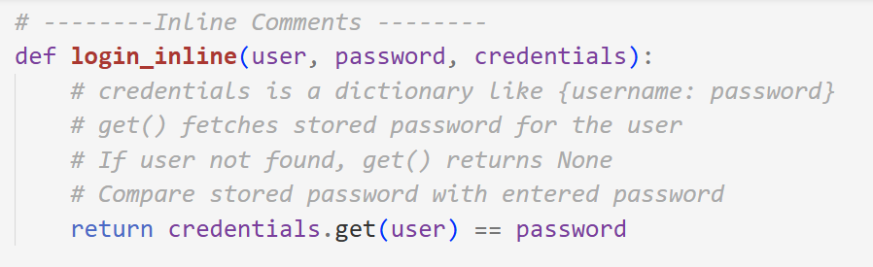
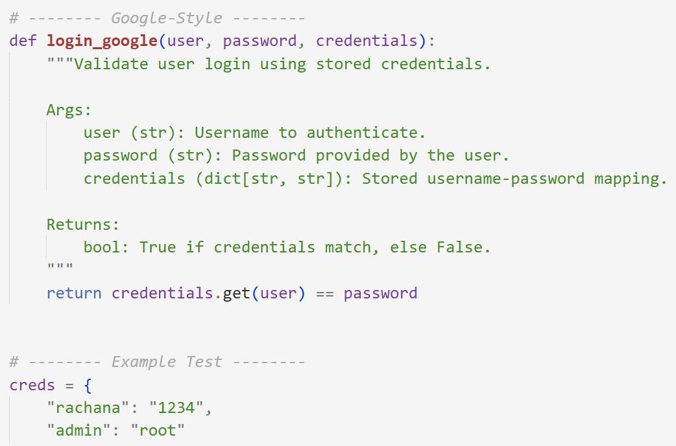
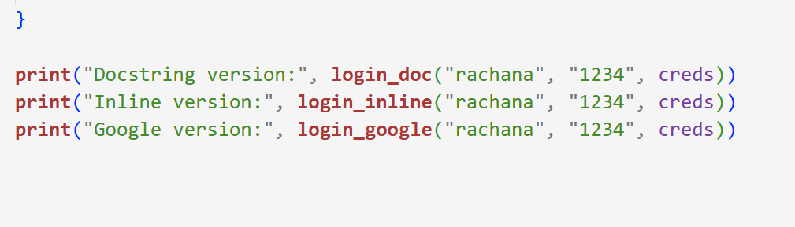
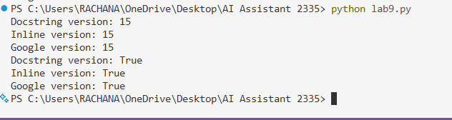
Description
This problem is about creating a login verification function that checks if the entered password matches the stored password for a given user. The main goal is to show how the same function can be documented in three different documentation styles. This helps understand how proper documentation makes code easier to read and maintain, especially for new developers joining a project.
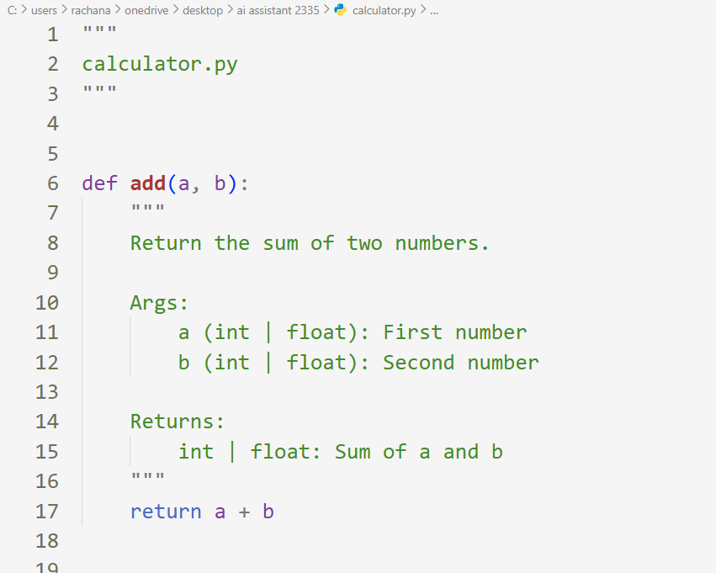
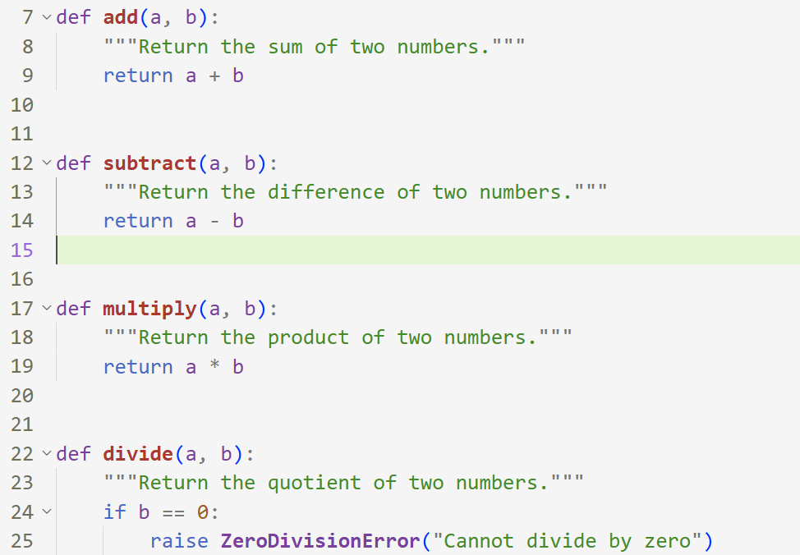
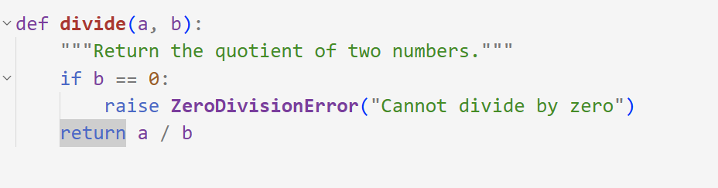
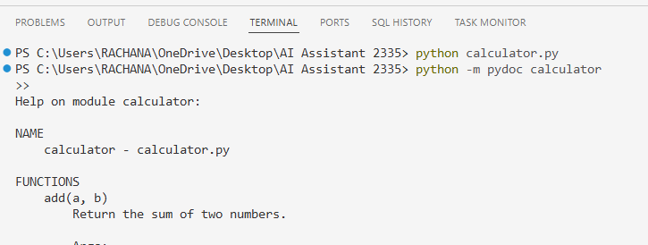
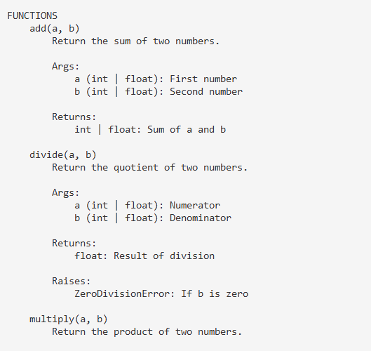
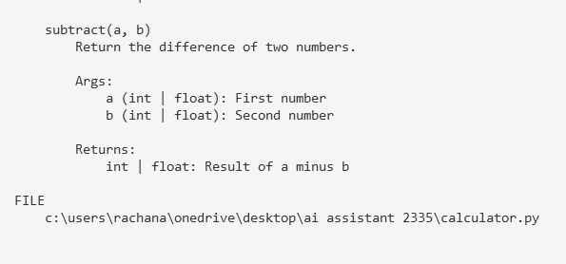
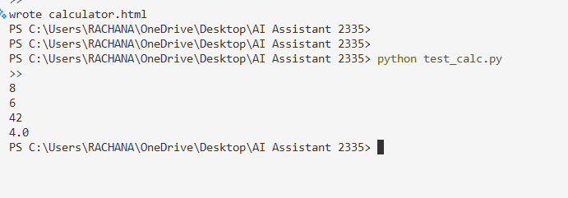
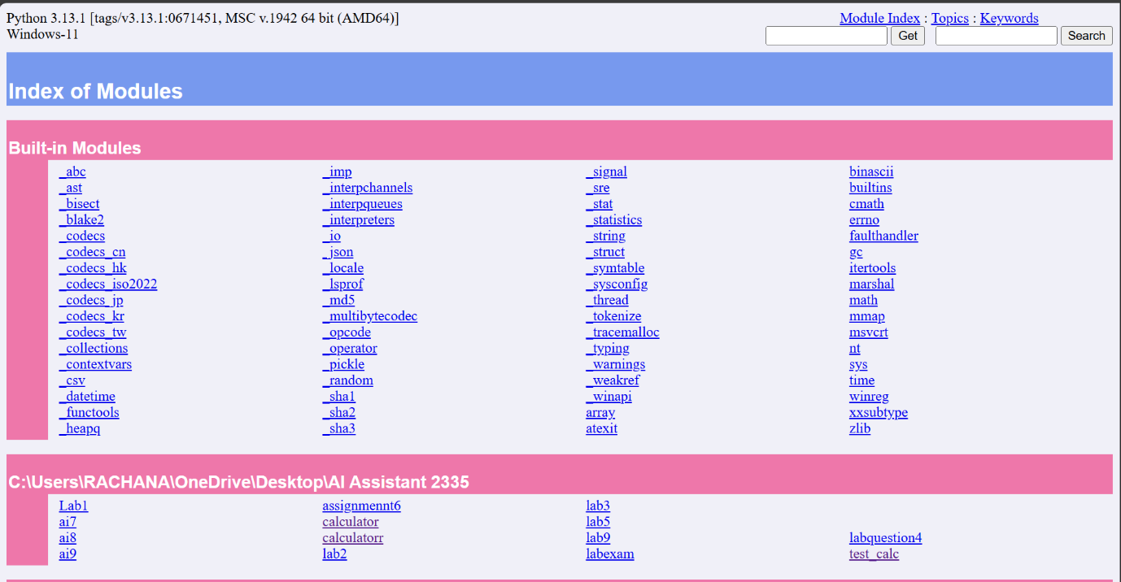
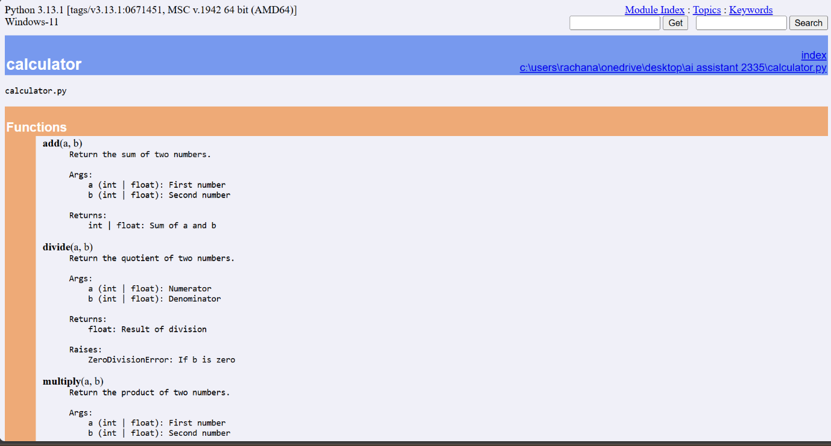
Result:
The calculator.py module was created with proper docstrings. Using the pydoc tool, automatic documentation was generated and displayed in a web browser. All arithmetic functions (add, subtract, multiply, divide) appeared correctly in the gen

